SQL DATABASE

Complete the following task:

Create a new database called "School" this database should have two tables: teachers and students.

The students table should have columns for student_id, first_name,last_name, homeroom_number, phone,email, and graduation year.

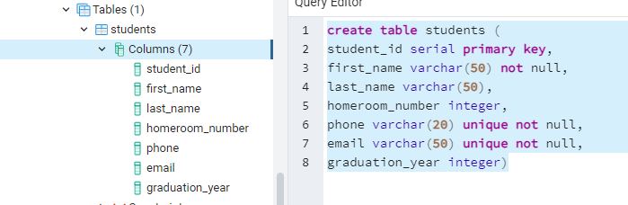

The teachers table should have columns for teacher_id, first_name, last_name, homeroom_number, department, email, and phone.

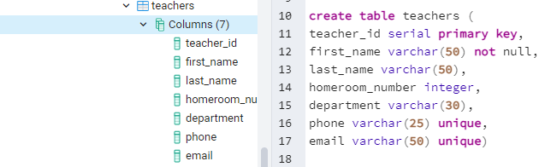

The constraints are mostly up to you, but your table constraints do have to consider the following:

* We must have a phone number to contact students in case of an emergency.
* We must have ids as the primary key of the tables
* Phone numbers and emails must be unique to the individual.

1. Once you've made the tables, insert a student named Mark Watney (student_id=1) who has a phone number of 777-555-1234 and doesn't have an email. He graduates in 2035 and has 5 as a homeroom number.

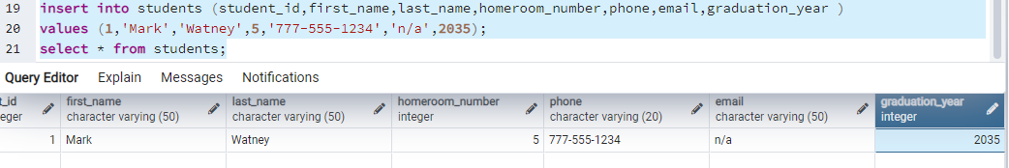

1. Then insert a teacher names Jonas Salk (teacher_id = 1) who as a homeroom number of 5 and is from the Biology department. His contact info is: jsalk@school.org and a phone number of 777-555-4321.

